
Turn a lidded Box Handout
By Walt Wager
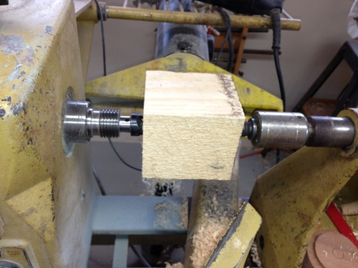 | Start with the box blank between centers - use a spur center in the head stock spindle and a cup center in the tail stock spindle.
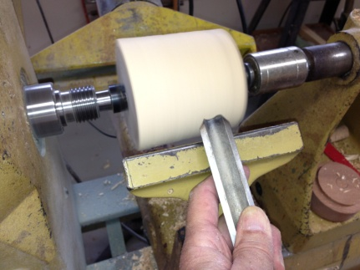 | Use a roughing gouge to round off the corners. Set the tool rest so you are cutting at the center of the blank. Remember the mnemonic -ABC;  Anchor - put the gouge on the tool rest,  Bevel - rub the bevel on the turning blank,  Cut - Lift the handle to pick up a cut
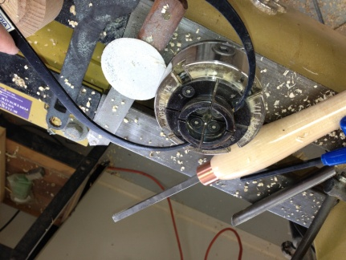 | In preparation for the next step, measure the outside diameter of the scroll chuck jaws. Have the jaws open about 1/8 of an inch.
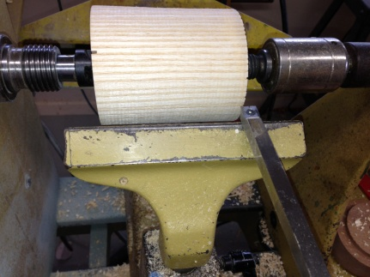 | Use the square easy-wood cutter or a bedan tool to cut the tenon to the approximate final size.
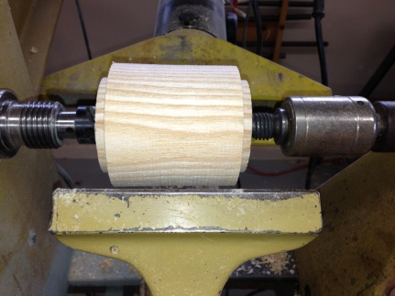 | Do this on both sides of the blank
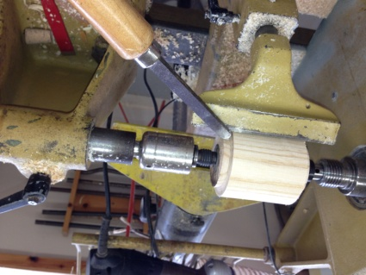 | Use the dove-tail scraper to shape the tenon. You want a clean corner and the bottom of the tenon to be perpendicular to the bed of the lathe so that the jaws of the chuck will sit firmly against the box blank.
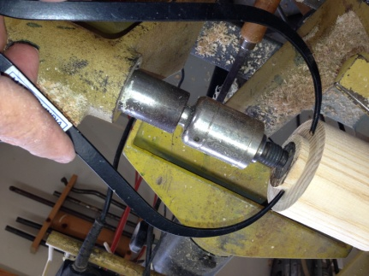 | Make the tenon the size you previously measured.
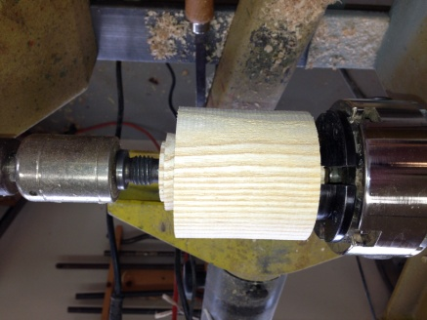 | Remove the blank from between centers and secure it in the chuck. Bring up the tail stock to support the box blank.
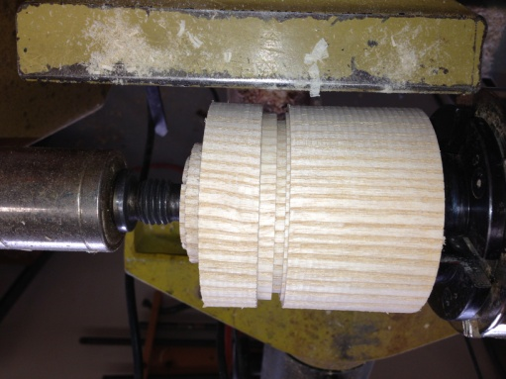 | The top (lid) will be about 1/3 of the way between the head stock and tail stock. Use the 1/8 inch parting tool to define the top, making three parallel cuts. Go as deep as the thickness you want the side of the box to be.  Next, part (cut) off the lid from the bottom close to the bottom (but leave a small lip to act as a gauge for fitting the top).
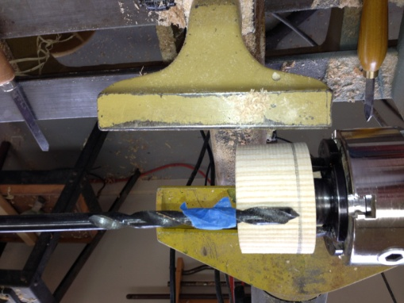 | Drill a hole to the depth of the box. Use tape as a depth gauge.
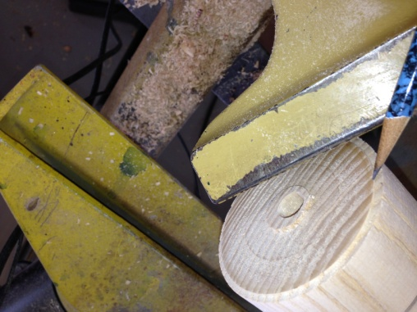 | Be aware of the small lip you left on the bottom. This is the same size as the lip on the lid, so when you hollow the box you know where the edge of the lid will fit - be careful when hollowing to only remove wood to the edge of this lip.
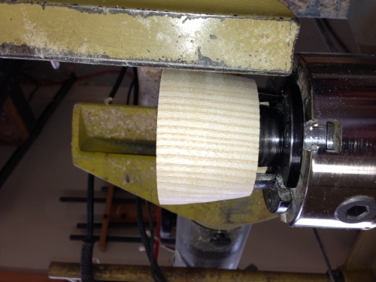 | Now would be a good time to shape the bottom of the box.
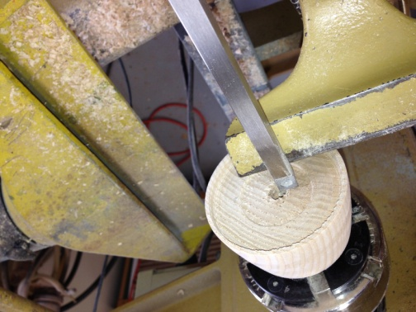 | When you hollow the box when using an easy-wood tool, start from the center, taking small bites, hollow out toward the lip going about 1/2" deep. After you have done this you can fit the lid in this opening. It should be very snug.
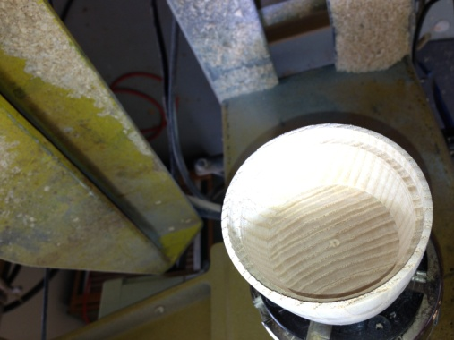 | Complete hollowing with the easy-wood tool until you reach the bottom of the hole you drilled.
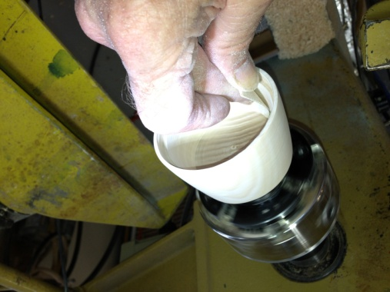 | Sand the inside of the box
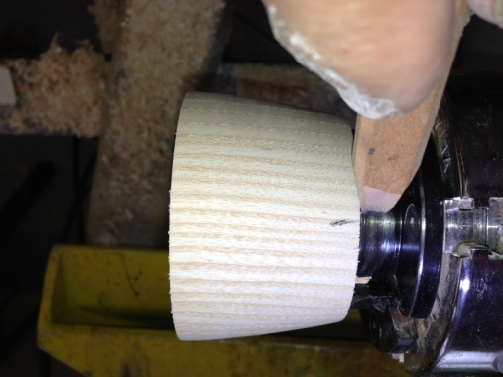 | Make a mark on the outside of the box next to the #1 jaw, so you can align it when you remount it.
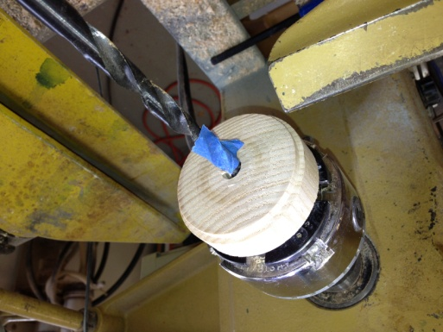 | Mount the lid and drill another depth hole (of course you have to move the tape).
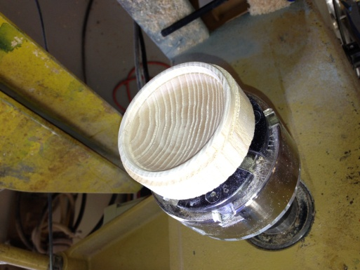 | Hollow and sand the inside of the box lid.
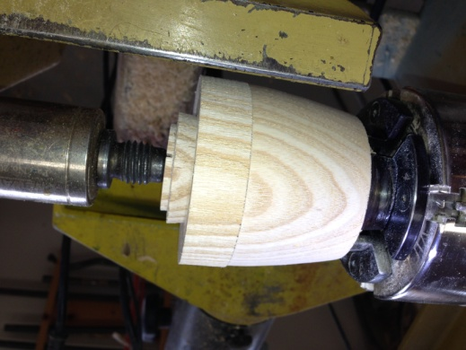 | Remount the bottom and secure the lid to the bottom with the tail stock. You can now shape the lid, removing the tenon or making it into a handle of some kind. Sand the lid.
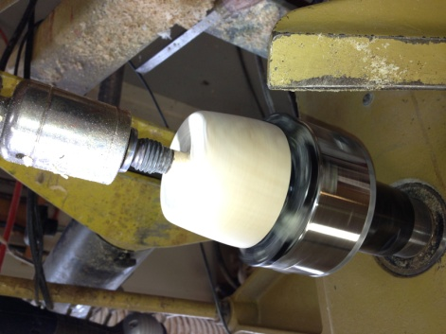 | Remove the lid from the bottom and rechuck the bottom using the scroll chuck in expansion mode or make a jam chuck, and remove the tenon from the bottom of the box - Finish the bottom.

