Project summary/abstract
Title: An exploratory longitudinal study of the systemic interventions for chronically low-performing schools in the State of Florida
Purpose: This study will longitudinally follow school improvement plans in several chronically low-performing schools in the State of Florida (from 2009 to 2014) to explore the relationship between various elements in the systemic interventions that the State and the districts provide to the schools and the outcomes at the school, class, and student level identifying connections between interventions and variables associated with student learning.
Selection and Description of the districts: (Kathy – we need your DOE input on this)
Description of the student population: (age groups, race/ethnicity, SES): and this
Description of the intervention to be developed: Florida schools enter differentiated accountability after missing Adequate Yearly Progress (AYP) for consecutive years starting from 2002-2003. The State of Florida has a tiered intervention system that provides strategies and support at the State, district, and school level. The intervention strategies address the following seven aspects: school improvement plan, leadership, educator quality, professional development, curriculum alignment, continuous improvement model, and monitoring processes and plans. Schools in different categories (based on AYP and school grade) receive different combination of strategies and support across the seven aspects.
Description of the control or comparison condition: Data will be compared among the districts and schools being studied. Since the study is looking to identify the effects of interventions on variables associated with student learning, we are hypothesizing that effective interventions will show increases in measures of moderating variables, which in turn will lead to increases in student learning. To the extent that schools employ similar interventions we would be comparing outcomes.
Description of the primary research method: The primary research method will be case studies that involve a district, and a school. Several chronically low-performing schools will be followed over time while they implement interventions to improve school grades and make AYP. Data on the intervention strategies (i.e., the aforementioned seven aspects) will be collected on each school and over time to explore the relationships between intervention strategies and school and student performance.
Description of measures and key outcomes: On the intervention strategies, data will be collected on whether certain intervention strategy has been implemented and the extent of fidelity and success of its implementation as reflected from the perspectives of district administrators, school administrators, and school instructional staff. The key outcomes include quality of classroom instruction, changes to school grade over time, AYP, and student performance in core subject areas.
Description of the data analytic strategy: The data analytic strategies include case analysis with qualitative data from different sources and methods for triangulation purposes and cross-case analysis to identify common effective intervention strategies. Multi-level models may be used to identify the strategies significantly related to student performance.
Project Narrative (25 single-spaced pages)
Significance of the study
A significant number of schools have been labeled "chronically low-performing schools," as determined by measuring annual yearly progress with standardized tests. A great deal of time, effort and resources are being applied to increase the effectiveness of these schools, and yet there is little empirical evidence that link interventions to student learning outcomes. In order to best allocate resources it is important to understand the effects of policy and intervention practices on student learning outcomes. In particular it is important to understand:
* How the components of policy and practice are aligned. How do schools interpret school improvement guidelines, how do they assign staff and adopt an implementation? What types of monitoring does the district provide and what are the resources that have to be redirected toward these interventions?
* How services can be aligned with the instructional programs of districts and with state academic, content, and achievement standards to maximize student learning. What effects do the districts and schools expect the interventions will have on student behavior and/or instruction? How does this affect variables associated with student learning?
* How resource allocation at the school-student level affects student learning. What are the costs of intervention in terms of resources and instructional engagement with the learners? What are the links between the intervening variables, learning variables and student achievement?

Research Plan:
Background
The U.S. Department of Education selected Florida to participate in the "Differentiated Accountability Pilot" initiative in 2008. Through Differentiated Accountability, or DA, the state is allowed greater flexibility in providing the needed technical assistance and interventions to the schools with greatest need. Florida's DA plan streamlines the federal and state accountability systems and directs increasing school-wide interventions and school and district accountability based on Adequate Yearly Progress (AYP) and school grade. This program allows FDOE to operate a new tiered approach to working directly with schools to increase student achievement. The support and assistance provided to each school is individualized depending on the needs of that school. Through DA, schools fall into a matrix of categories based on the level of the school's achievement. The lowest performing schools receive the most support, and under DA, these schools are required to implement the most robust interventions that will help lead to successful school improvement. In order to provide direct support to schools, Florida has created a regional system of support.
Regional Support System
Through Differentiated Accountability, Florida is divided into five regional centers and Regional Teams provide direct assistance to schools and districts in their region. Each Regional Team works with struggling schools by assessing what assistance each school requires and then providing that assistance directly to the school and in partnership with the districts. The areas of need that are addressed by the Regional Team include: curriculum and instruction, school leadership, school improvement planning, professional development, teacher quality, and continuous school improvement. Further information about the responsibilities of each member of the Regional Team is listed below.
• Regional Executive Directors (REDs) are change agents with a prior record of success in improving student achievement. Regional Executive Directors support school improvement efforts in the region, build district capacity, provide and broker professional development, and coach and mentor school principals and the school and district leadership teams.
• Instructional Specialists are experts in primary and secondary curriculum and pedagogy and have content-area knowledge. Instructional Specialists monitor instruction, support the development and evaluation of district and school improvement plans, monitor the implementation of interventions, and provide other school improvement support services. Each Regional Team includes Instructional Specialists in reading, mathematics, science, and Response to Intervention (RtI).
• Connecting Partners broker services to districts and schools, such as Reading First Professional Development Coordinators, Response to Intervention (RtI) Project, William Cecil Golden, the Positive Behavior Support Project, Institutions of Higher Education, business organizations, and public and private consortiums
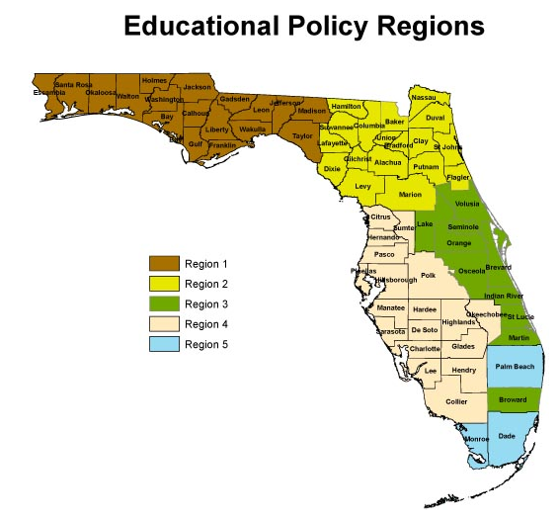
Schools
Low performing schools are identified for Differentiated Accountability based on schools' performance as measured by school grades determined by student performance on standardized tests and Adequate Yearly Progress.
The Classification System places the schools into one of four quadrants depending upon its school grade and the amount of time it has been deficient. As shown in Table 1, the Criteria and intervention are specified for each of the following quadrants: Prevent I, or Prevent II, Correct I, or Correct II. The other category is "Intervene". The state assigns a team of professionals to work with the district and the school(s) for Correct II and Intervene.
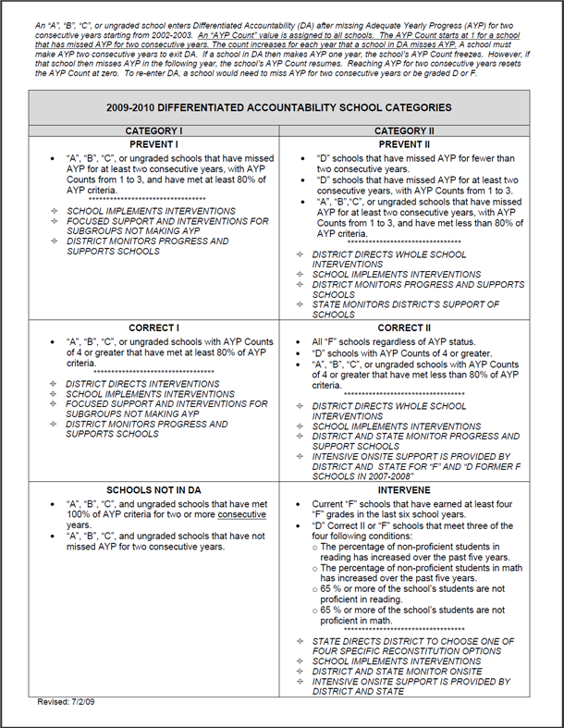
The schools in a region are then listed with regard to their school grade and the differentiated accountability category they fall into, for example,
District School Category
33 | JEFFERSON | 0021 | JEFFERSON COUNTY MIDDLE/HIGH SCHOOL | 1 | F |  | NO | 72 | 6 | PREVENT II | INTERVENE
33 | JEFFERSON | 0111 | JEFFERSON COUNTY ELEMENTARY SCHOOL | 1 | C |  | NO | 87 | 6 | CORRECT II | CORRECT I

Every school district prepares a District improvement plan and every school is responsible for a school improvement plan. These plans conform to a template that provides demographic and performance data with regard to school annual yearly progress (AYP) in reading and math. In some cases specific interventions are specified for specific problems, e.g., a specific math curriculum for a school not meeting it's math AYP. In some plans there is less information about specific interventions.

The state provides a series of matrices of different categories and interventions, for example the category of School Improvement Planning recommends the following:
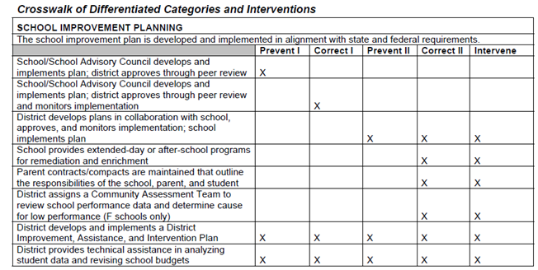
These matrices provide guidance to the schools about suggested intervention according to the level of need. These interventions should be reflected in the district and school improvement plans. Our observation of the plans shows that the detail in the school plans varies widely. One could predict that a district or school with a more complete plan would be more likely to implement the interventions than a school with a less complete plan.
While the district assigns a community assessment team to review school performance and determine the cause for low performance, there is little information to determine why the intervention might have worked or failed with regard to mediating variables associated with student learning. The purpose of this research is to explore the interventions proposed, and implemented at low performing schools with regard to variables associated with appropriate student behavior and improved student learning.
School reform involves making changes to the administration, school management, physical plant and instruction. The overall intent is to improve student learning retention and graduation. To this end, it should be possible to map the methods and practices of school reform to mediator variables, and in turn those mediator variables to variables associated with student learning.

Linking interventions to student learning:

John Carroll's Model of school learning takes into consideration both student and context variables as the affect student learning. The degree of learning that takes place, according to Carroll, is a function of the time a learner needs to learn, over the time a student spends in learning. The variables time needed and time spent can also be decomposed into the following variables.

Aptitude - (Measured as subject specific knowledge and skills, Eg., aptitude for science.)
Aptitude affects the time needed -- the more someone knows about a particular subject, the quicker they can learn new knowledge and skills associated with that subject. Aptitude can be measured in a number of ways including subject specific tests, project activities or demonstrations of student performance. Aptitude is important in identifying prerequisite competencies for learning in domains where the learning of a new skill depends upon the recall and application of a previously learned skill(s). For example in order to learn a spelling rule like "i before e except after c", the concepts of before, and except have to be mastered.

Attitude - (Measured as perception of self as a school learner.)
Attitudes are conceived of a choice behaviors -- the student chooses to think that mathematics is important, this is reflected in how the student talks about mathematics, pays attention in class, does her homework, etc. Attitudes are malleable. A teacher communicates a positive attitude through their enthusiasm and approach to the the subject. A teacher can communicate a positive attitude with the idea that everyone in the class can learn this, or a negative attitude with the notion that the subject is going to be difficult and that everyone will not succeed. A teacher's attitude toward spending extra time with students who lack prerequisites or need more examples, builds more positive student attitudes towards both the teacher and the subject she is teaching.

Perseverance/ Motivation -- (Measured as the time spent on a learning task.)
John Carroll's model recognizes that learning takes time and students who spend more time learn more. There is good evidence for this from studies done by Sam Postelwaite in the 60's at Purdue University, where he found a high correlation of students' grades in his course with the amount of time they logged in the learning center. However, Carroll recognizes that some students will take less time than others when learning the same skills. This is most probably because they have a greater knowledge structure of the topic being learned. Robert Gagne referred to this as prerequisite knowledge or cognitive structure.

Time allowed -- (Measured as availability of human and mediated resources.) Even if a student is highly interested in a subject and willing to put in the time needed to learn, it will take them longer if they don't have access to resources from which to learn. If the knowledge can only be gained in the classroom, because of a lack of text books or on-line materials, then the time allowed to learn is severely limited. Technology, when appropriately employed, extends the time allowed to learn. Technology can also extend and leverage the ability of the teacher to help students by posting examples, using discussion boards, e-mail and other communication devices. One interesting question is the return on investment in terms of student learning, for money spent on technology and making resources available to students outside the classroom.

Quality of Instruction -- (Measured by time needed by average learner.)
According to Jack Michaels at Western Michigan University, Good instruction has three attributes: it is well sequenced, it is complete, and it lacks irrelevant material (it is focused on the learning outcomes.) Robert Gagne separates teaching from learning in that the purpose of teaching is to facilitate learning, and this is done, according to Gagne, by providing what he calls the events of instruction. The events of instruction include: 1) gaining student attention, 2) Establishing expectations, 3) recalling prerequisite skills, 4) providing new information, 5) providing learning guidance, 6) eliciting student performance, 7) providing feedback, 8) assessing performance, and 9) providing for retention and transfer. A well designed lesson will provide many of these events, a poorly designed lesson may only provide event 4 (new content). The quality of a lesson might be assessed by the number of events included.

Learning (study) skills -- (Measured by approaches to learning and desired learning context.)
One might hypothesize that poor learners have poor study skills -- they don't have the habits and context for learning. They might also have physical or mental learning disabilities that make it difficult for the to read, or process material. Teachers should know something about the study habits and learning skills of their students, and it would be interesting to record how teachers get this information and what they do with it.

Relevance -- Measured as student's perceived interest and importance of a learning task.)
Relevance is probably highly correlated with motivation and perseverance. If a student see the reason for learning, and can relate that to their life in either to the immediate or near future, they are more likely to spend the time needed to learn. One question is to what degree to teachers in the classroom try to make what they are teaching relevant to their students.

Each of the variables above are malleable to some degree. The question is how do school turnaround procedures affect these factors and to what degree are the administrators, teachers, staff and students aware of how changes in the school foster practice that affects learning. This is what we hope to study in this exploratory study of low performing schools that have been taken over by turnaround teams.
Other studies of School reform. There is a significant amount of literature on the condition of education and school reform, including for example, the MCREL Final Report: High Needs Schools – What does it take to beat the odds?; the Annenberg Report, Putting Kids on the Pathway to College; ACT’s report, The forgotten Middle, The IES reports, The Condition of Schools, and Turning Around Chronically Low Performing Schools.

Method:
Need a better description of the study design – I has a resource for this.

Teams of researchers, each team including the regional team, a senior researcher, two research assistants, and an assessment specialist will work with the state and district school office to measure and assess variables associated with school reform and student learning. The learning variables to be investigated include, but are not limited to those identified above.
Some team members would serve on more than one team, while other team member would stay with a single team. For example the Regional team, senior researcher, and assessment specialist would be on multiple teams, while two research assistants would be assigned to one school. We are anticipating four teams, working in four schools, so there would be eight research assistants.

The framework for interventions presented in Turning Around Chronically Low Performing Schools, would be used for associating interventions being investigated with resources, mediating variables, managerial and instructional practices, then to learning variables, and ultimately to evidence of student learning. Table 2., shows a portion of the matrix that would be used, and hypothetical relationships among these variables. Table 2., will be used as a framework for collecting data and making hypotheses about causal relationships. As an exploratory device, it can add information to the anecdotal data presented in the IES, Turning Around Schools report. The table can be expanded to allow for intervening or concomitant mediating variables hypothesized to impact other mediating variables. We would be gathering data to test these relationships.

Table 2
Example of a matrix of Interventions by Mediating variables/resources/ and hypothesized outcomes
Matrix relating interventions to mediating variables, resources and variables associated with learning.
Interventions (from the IES Practice Guide, "Turning around chronically low performing schools." | Mediating malleable variables | Additional resources applied | Anticipated effect leading to learning improvement | Student Performance
Signal the need for dramatic change with strong leadership
change the leadership | Teachers (T) attitude toward teaching.  T attitudes towards administration.  T attitudes towards students | New leader | better instruction,  better use of student time | test scores
present leader alters leadership practices | changed perceptions of teachers | more time spent engaging students | increase in student motivation | test scores  self efficacy scores
increase leadership presence in classrooms | changed perceptions of students and teachers | more time spent engaging students | increase in student motivation
Make agenda for change public with anticipated actions | Changed perceptions of parents, taxpayers | Advertising, community meetings, web presence | Increase in time spent outside of school.
Maintain a constant focus on improving instruction
Use data on student achievement to identify gaps in student learning. | Diagnostic test scores | tutors | Improved aptitude | test scores  self efficacy scores
Build a committed staff
Assess the strengths and weaknesses of the staff. Identify staff who are not fully committed to the school turnaround goals or who don't have the qualifications to carry them out. | Terminal degree  Year earned  Time in service  Teaching in or out of field  Etc. | Teacher development – workshops  Teacher Aids | Improved instruction | Formative test scores  Summative test scores  Teaching Assessment by Students
Redeploy staff members who are not effective in their current role | Criteria for redeployment  Attitude toward redeployment  Effectiveness in new role | Cross training  Replacement teacher | Improved instruction  Learner appropriate instruction  More time engaged in learning | Formative test scores  Summative test scores  Teaching Assessment by Students
Replace staff members who actively resist the school turnaround efforts. | Criteria for replacement | Buyout costs  Replacement costs | Better classroom management and instruction.  More time on task. | Formative test scores  Summative test scores  Teaching Assessment by Students
Recruit new staff who have the needed specialized skills and competencies for positions in the school - such as reading teachers, interventionists, mentors, and instructional coaches. | Criteria for recruiting | Start-up costs  Continuing costs | Differentiated instruction  More time engaged in learning  Better student behavior and attitudes | Formative test scores  Summative test scores  Teaching Assessment by Students
The matrix would continue and contain all the interventions discussed in Turning Around Chronically Low-Performing Schools

Some of this has to be a part of the proposal- considered before submitting the proposal because it affects budgets.

The sequence of action includes the following steps:
The research districts would be identified by the PI, DOE designates (Think about logistics – travel and access to people).
The research teams would be constructed
The team would familiarize itself with the history of performance of the school, including ethnographic information about the history of the school leading to its present organization. The performance of the school would be tracked back as far as possible to identify the past performance of the school.
The team would review the District and school improvement plans and identify the interventions proposed for the schools.
The interventions would be fit into the proposed framework under one of the major categories
The hypothesized mediating variables would be identified and linked to one or more student learning variables.
Existing observation forms and instruments would be indentified and monitored. (Include in Appendix)
Additional observation forms would be developed as needed.
Student data would be used to describe the current student demographic.
Student artifacts would be reviewed and measured
Classroom observations and student behavior and performance data would be collected to and linked to interventions.

Data analysis:
The state DOE has a number of forms (examples are included in the appendix) that are used to collect data with regard to school improvement plans, compliance, etc. that would be used to compare districts and schools with regard to differentiated accountability. Other data would be collected to assess the cost of interventions and the allocation of resources. These same data would be collected and compared across the years of the study. In addition, qualitative data would be collected with regard to the degree to which teachers perceive that that selected intervention affect what they do in the classroom and how that impacts variables that affect student learning.
In addition, student performance data, formative and summative, from classroom exercises and/or assessments would be collected to assess student progress during the school year and to compare end of year progress to progress made in previous years. We will look at individual as well as collective improvements in student learning in selected subject areas.

Personnel - Need short Bios from all the researchers, and full vitaes or resumes.
Walter Wager - Senior researcher associate, is the interim Assistant Dean and Director of the School of Teacher Education at FSU. Dr. Wager was a Professor of Instructional Systems Design for 35 years, and has taught courses in Curriculum Design, Instructional Materials Design, and Teaching Skills for College Teachers. He is co-author of the text Principles of Instructional Design, now in its fifth edition and one of the leading texts in the field. Dr. Wager was also the Director of Faculty Development at Florida State University for eight years, and he presents workshops on instructional strategies and the integration of educational technology at other US and international universities.
Resources (I am assuming they mean budget here - have to check this.

This is not (I repeat not) a real budget – nor does it contain all the participants – I would think we have to build some incentive in for the district and school personnel for their time, and however DOE and MGT feel they should be included – This needs much work.

Budget
Personnel: |  |  |  |  |  |  |  | Assigned time |  | wages |  | benefits | individual | total
2 |  | DOE liaison |  |  |  |  |  | 0.25 |  | 25000 |  | 6500 | 31500 | 63000
1 |  | PI |  |  |  |  |  | 0.2 |  | 20000 |  | 5200 | 25200 | 25200
2 |  | Senior researcher |  |  |  |  |  | 0.5 |  | 50000 |  | 13000 | 63000 | 126000
8 |  | research assistants |  |  |  |  |  | 0.5 |  | 20000 |  | 5200 | 25200 | 201600
2 |  | assessment specialist |  |  |  |  |  | 0.5 |  | 50000 |  | 13000 | 63000 | 126000
 |  |  |  |  |  |  |  |  |  |  |  |  |  | 541800
Travel
 |  | local @ .49 mi |  |  |  |  |  |  |  |  |  |  | 20000 | 20,000
 |  | Conference travel to Washington |  |  |  |  |  |  |  |  |  |  | 3000 | 3000
 |  | perdiem |  |  |  |  |  |  |  | 200 days@$200 |  |  | 40000 | 40000
 |  |  |  |  |  |  |  |  |  |  |  |  |  | 604800
overhead
 |  | 46% |  |  |  |  |  |  |  |  |  |  |  | 278208
 |  |  |  |  |  |  |  |  |  |  |  |  | total | 883008

Appendix A (15 page limit): figures/charts/tables that supplement the research text, examples of measures to be used in the projects and letter of agreement from partners (e.g., schools) and consultant.

…

