Widma Cu symulowane 2.05 2.05 2.25 30 30 200

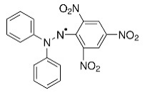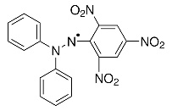









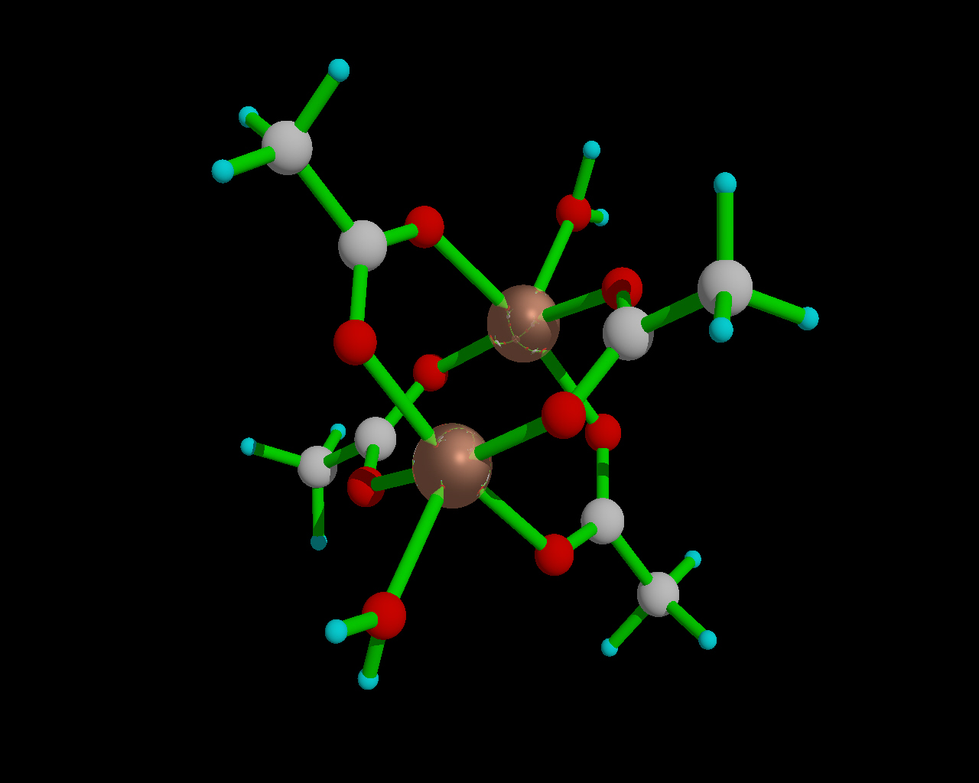

**Copper Acetate Monohydratethe first binuclear metal complex ever studied by EPR  
‘Anomalous Paramagnetism of Copper Acetate’ B. Bleaney, K. D. Bowers  
Proc. Roy. Soc. London, Series A, 214, 451 (1952)**





$$χ_{\text{dimer}}=\frac{Ng^{2}μ_{B}^{2}}{6kT}\frac{6e^{-J/kT}}{1+3e^{-J/kT}}$$ $χ_{\text{monomer}}=\frac{Ng^{2}μ_{B}^{2}}{3kT}\frac{3}{4}$

**Energy [J]**

**-8**

**-6**

**-4**

**-2**

**0**

**2**

**4**

**6**

**S = 0**

**S = 5**

**S = 1**

**S = 4**

**S = 2**

**S = 3**

**Figure 2**. ORTEP view and atom numbering scheme for [Cu3(*o*-methoxybenzoato)4 (H2TEA)2]∙2(C2H3N) (**2**). Thermal ellipsoids are drawn at the 40% probability level**.** Hydrogen bonds are drawn as dashed lines. The solvent molecule and C-H hydrogen atoms are not shown for clarity. Central and terminal Cu coordination polyhedra are also shown.



