Sequential Analysis of Causal Map Drawing Behaviors

Woon Jee Lee
wl08c@fsu.edu
Instructional Systems Program
Educational Psychology & Learning Systems
Florida State University

Allan Jeong
ajeong@fsu.edu
Instructional Systems Program
Educational Psychology & Learning Systems
Florida State University

Lee, W..J. & Jeong, A. (2011). Sequential analysis of causal map drawing behaviors. Paper presented at
the 2011 Association of Educational Communications and Technology conference, Jacksonville, FL.

Descriptors: Concept mapping, interaction analysis

Sequential Analysis of Causal Map Drawing Behaviors
Woon Jee Lee & Allan Jeong
Introduction

According to Jonassen (2000), the 21st century requires people to apply reasoning processes to solve complex problems (e.g., making predictions, inferences, drawing implications, articulating explanations). These processes are usually applied in learning tasks to achieve conceptual understanding and to perform problem solving. Jonassen (2000) proposed using causal maps to facilitate the reasoning process because causal maps enable learners to visualize the causal relationships between variables and then articulate, explore, and assess their understanding of complex problems. In recent years, computer-supported mapping tools have increased in numbers: CmapTools (Ifenthaler et al., 2009), Ulysse (Desthieux et al., 2010), STELLA (Schecker, 1994), and jMAP (Jeong, 2009). However, a limitation of these studies is that students were not given empirically tested guidelines on how to draw more accurate causal maps. Few studies have examined and tested what processes lead students to construct higher quality maps. The purpose of this study was to determine what behaviors and sequences of behaviors performed during map construction might lead students to create better causal maps. As a result, the research questions addressed in this study were the following:
- What behavioral patterns exist when students are constructing causal maps?
- How do sequential behavior patterns differ between students that created more accurate maps and students that create less accurate maps?

Method
Participants
In fall 2010, 18 graduate students (3 males, 13 females) enrolled in the Learning Cognition course at a large southeastern university. Students were taken from programs of Elementary Education, Counseling Psychology, Instructional Systems, and Foundation of Education.

Procedures
Students were given 50 minutes to apply concepts and principles from reinforcement theory to produce a causal map conveying the optimal way to sequence stimulus, responses, and response contingencies to achieve desired behavioral changes. To draw the maps, students used jMAP - a computer-based mapping tool developed by Jeong (2010). The entire processes of drawing causal maps were recorded using a computer screen capture program. Students’ causal maps like in Figure 1 were assessed by matching identified links and link attributes (e.g., direction, impact, contingence) with those in an expert map.

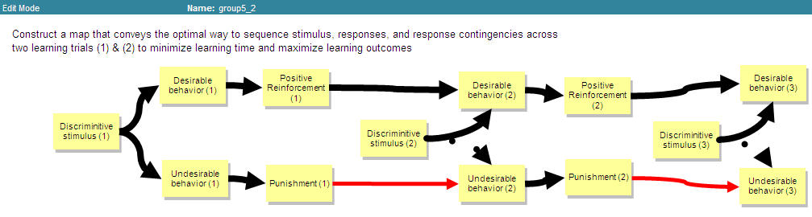

Figure 1. Example of student’s causal map
Sixteen videos were produced to capture students drawing sessions (two missing data due to technical problems). For this case study, the video recordings of three students that scored high in accuracy and three students that scored low in accuracy were analyzed to identify potential differences in map construction behaviors.

Sequential Data Analysis
Each student’s actions were coded into any one of the six following categories:

N: make a change on the initial position of a node
R: make additional changes to position of a node
S: simultaneously shift position of a group of nodes
L: create a link between nodes
A: change attributes (impact, direction, probability) of a causal link
C: change a link to point from one node to another

The sequential data was coded and aggregated into one data file for students who created maps of high accuracy and another file for students who created maps of low accuracy. Using the Discussion Analysis Tool (DAT) developed by Jeong, the sequential data was converted into frequency matrices to reveal how often each action was immediately followed by another action. probabilities and z-scores were then computed (Table 1) to determine the probabilities in which one action was performed immediately following another action and whether or not the observe probability was significantly different from the expected chance probability. Transitional diagrams for each group (Figure 2) were then produced with DAT to visually convey the observed transitional probabilities.

Table 1 Frequency matrices and transitional probabilities matrices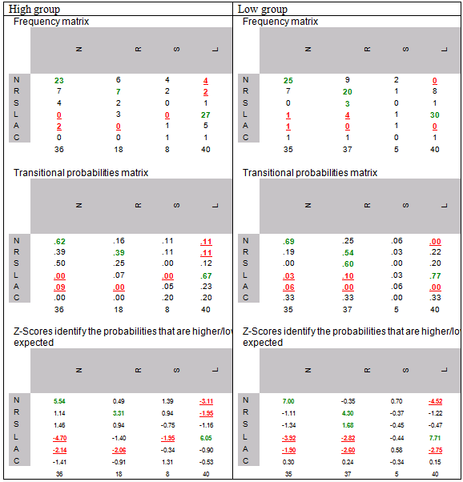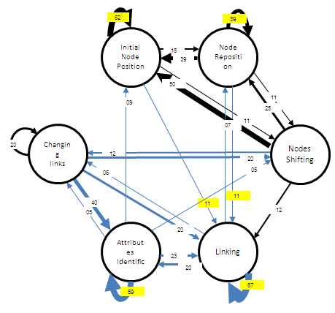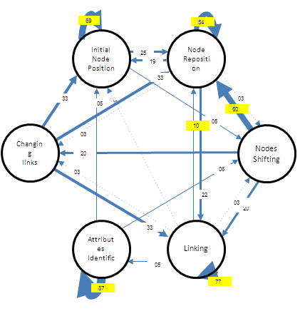
Figure 2. Transitional diagrams for the high (top) and low accuracy group (bottom) with significant probabilities highlighted in yellow.

Results

Some differences in behavioral patterns can be observed when we compare the two state diagrams in Figure 2 and trace through the sequences of possible actions based solely on the transitional probabilities that were found to be significantly above chance and/or expected probabilities. The transitional diagram of students with high accuracy maps shows that when this group of students changed the initial position of one node, they were very likely to follow that action by changing the initial position of yet another node and so on (62%). The next possible action that was most likely to follow was the creation of links to connect one node to another node (11%). Once a link was created, the next likely action was to create yet another new link (57%). Therefore, a typical behavioral sequence performed by this group might look like I-I-I-L-L-L. In contrast, the diagram for students with low accuracy maps shows that they began adding links to connect nodes only after they had re-positioned a node on their map (11% of the time) as opposed to changing the initial position of a node. Furthermore, the low accuracy students repositioned nodes a total of 36 times, where as the high accuracy students repositioned their nodes only 18 times. And once they started adding a link, these students were 20% much more likely to continue adding more links (77%) in comparison to the high accuracy group (57%).

These noted differences in behavior patterns may suggest that high accuracy students may alternate more frequently between positioning nodes and adding links between nodes during the map construction process than low accuracy students. This type of behavior seems to suggest that high accuracy students may be using a more systematic and step by step approach to temporally and/or sequentially sequence one node after another node. In doing so, each time a node is positioned and linked produces constraints on what subsequent causes or effects should be considered, moved into positioned and linked to the current map. In contrast, the low accuracy students tendency to move and reposition nodes more extensively followed by heavy activity creating and linking nodes suggests the possibility that these students did not use the visual spatial (and possible temporal) organization of the nodes to help them isolate and identify the correct cause effect relationships between the nodes. Given that temporal flow in causal maps tends to be found in maps of higher accuracy than in maps of lower accuracy (Lee & Jeong, 2010), these differences in behavioral patterns might serve to explain the observed differences in map accuracy.

Implications for Future Research
This study presented valuable insights into students’ behaviors when drawing causal maps. For the future research suggestion, a large number of cases of student’s map drawing demonstration should be analyzed to produce more reliable frequencies of students’ behaviors. The future research also may examine correlations between each probability of sequential behavior and key elements in causal maps such as total number of links, temporal flow and node distance. Students’ prior knowledge should be controlled to avoid possible threaten of internal validity. Finally, the cause effect relationship between observed processes and their effects on map accuracy must be tested in controlled studies by requiring students to use specific processes and by comparing the results of using one particular process over another process.

References

Bakeman, R., & Gottman, J. (1997). Observing interaction: An introduction to sequential analysis. Cambridge, UK: Cambridge, University Press.
Desthieux, G., Joerin, F., & Lebreton, M. (2010). Ulysse: a qualitative tool for eliciting mental models of complex systems. System Dynamics Review, 26(2), 163-192.
Jeong, A. (2010). jMAP. Retrieved February 10, 2011 from http://cscl.wikispaces.com/jmap.
Jeong, A. (2009) Superimposing individual and group casual maps to trigger critical discourse and change in learners’ casual models. Paper presented at the American Educational Research Association conference, San Diego, CA.
Jeong, A. (2005). A guide to analyzing message-response sequences and group interaction patterns in computer-mediated communication. Distance Education, 26(3), 367-383
Jonassen, D.H. (2000). Toward a design theory of problem solving. Educational Technology Research & Development, 48(4), 63-85.
Jonassen, D.H., & Ionas I. G. (2008). Designing effective supports for casual reasoning. Educational Technology Research and Development, 56, 287-308.
Ifenthaler, D., Masduki, I. & Seel, N.M. (2009). The mystery of cognitive structure and how we can detect it: tracking the development of cognitive structures over time. Instructional Science. doi: 10.1007/s11251-009-9097-6
Lee, W. J., & Jeong, A. (2010). The relationship between accuracy and attributes in students' causal diagrams, total links, temporal flow,and node positions. Proceedings of the 2010 Association forEducational Communications and Technology conference, Anaheim, CA.,1, 146-155.

