The effects of writing skills on student interactions in online debates

Allan Jeong
ajeong@fsu.edu
Instructional Systems Program
Florida State University

Haiying Li
haiyinglit@gmail.com
Institute for Intelligent Systems
University of Memphis

Jiaren Pan
andy.c.pan3@gmail.com
Instructional Systems Program
Florida State University

Descriptors: computer-mediated discussions, interaction analysis

The effects of writing skills on student interactions in online debates
By Allan Jeong, Haiying Li & Jiaren Pan
Florida State University
Abstract
Because verbal fluency influences perceived competence and credibility, this study identified differences in ways students respond to messages posted by students with low versus high writing ability in online debates and asynchronous threaded discussions. This study found that arguments posted by students that exhibited poorer grammar/spelling elicited 57% more responses that challenged the credibility or merits of the arguments than arguments posted by students that exhibited better grammar/spelling. The implications for instruction and future research are discussed.
Introduction
Collaborative argumentation is an instructional activity for fostering critical discussions in both face-to-face and online environments. Argumentation involves the process of building arguments to support a position, considering and weighing evidence and counter-evidence, and testing out uncertainties to extract meaning, achieve understanding, and examine complex ill-structured problems. This process not only plays a key role in increasing students’ understanding but also in improving group decision-making. Online discussion boards are being increasingly used to engage learners in dialogue in order to promote more in-depth discussions. However, studies show that the quality of online discussions is often shallow.
Given that argumentation is both cognitive and social in nature, social dynamics can often come into play in ways that inhibit or facilitate argumentation. For example, a previous study showed that arguments presented in a conversational style (with greetings, emoticons, acknowledgements, addressing others by name) elicited 41% more replies that challenged the merits of the argument than arguments posted in an expository style. Challenges presented in a conversational style elicited up to eight times more responses providing further explanations for a given argument. Studies like this illustrates how certain characteristics of the message that can be intentionally manipulated by students can influence how students interact with one another in online debates.
The purpose of this study was to examine how grammatical/spelling errors influence how likely students respond to arguments with challenges and respond to challenges with counter-challenges versus explanations versus supporting evidence. The rationale for examining their effects is based on findings from human communication research showing that a speaker’s verbal fluency can affect how others perceive the competence, credibility and persuasiveness of the speaker (Burgoon, Birk & Pfau, 1990). As a result, this study hypothesized that: a) arguments are more likely to elicit replies that challenge their arguments when arguments are posted by students with low writing ability than by students with high writing ability; and b) challenges posted by low ability students are more likely to elicit counter-challenges than challenges posted by high-ability students. The questions examined in this study were:
- What differences exist in the response patterns to arguments, challenges, explanations, and evidence posted by students with low versus high writing abilities?
- What differences exist in response patterns produced in exchanges between low-to-low ability students versus high-to-high-ability students?
Method
The participants were 72 graduate students from four semesters of an online course on distance learning at a large southeastern university. Each student participated in four online debates hosted in Blackboard discussion forums. Each class was divided into supporting and opposing teams to debate for or against a given claim. Students were required to insert a tag into the subject heading of each posting to identify the posting as a supporting or opposing argument (+ARG /–ARG), a challenge (+BUT/-BUT), explanation (+EXPL/-EXPL), and supporting or counter evidence (+EVID/-EVID) with + and – tags to identify team membership.
Each student’s postings was copied and pasted into MS Word and the number of unique grammatical and spelling errors was counted. Each student was scored on their writing ability by taking the total number of errors (M=4.96, std=6.99) observed across all the student’s postings divided by the total number of words (M=513.39, std=565.8) contributed by the student. The 72 students were rank ordered on writing ability and the median score was used to divide the students into low (n=29) and high (n=43) ability group.
The message tags were modified to identify type of posting and writing-ability group (i.e., ARGH=argument posted by high-ability student, ARGL=posted by low ability student). The Discussion Analysis Tool developed by Jeong (2005) was used to tally the number of times each type of message was posted in reply to one another to generate the frequency and transitional probability matrices below. The right matrix shows for example that arguments posted by low ability students (ARGL) elicited challenges (BUT) in 58% of the responses to the arguments. In contrast, arguments posted by high-ability students (ARGH) elicited challenges in 41% of responses. These probabilities were then graphically conveyed using transitional state diagrams presented below.
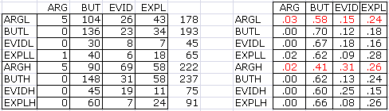

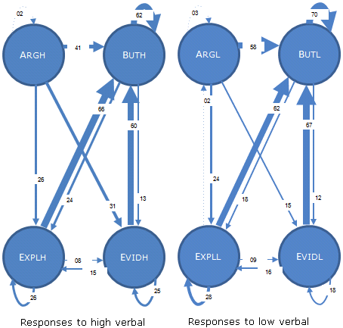

Results
The state diagrams show that the response patterns to messages posted by high versus low ability students are similar overall. However, the differences in the distribution of responses to arguments posted by low versus high-ability students was found to be statistically significant, χ²(3)=18.1, p= .000. Significant differences were found in the mean number of challenges posted in reply to arguments posted by low (M=.93, std=1.03, n=112) versus high (M=.59, std=.82, n=248) ability students, t=-3.30, df=358, p=.001. Arguments from low ability students elicited 57% more challenges (ES=+0.18) than arguments from high-ability students. The differences in distribution of responses to challenges, explanations, and evidence were not statistically significant.
Additional comparisons showed significant differences in the distribution of responses to arguments (χ²(3)=19.8, p=.000) and to challenges (χ²(2)=9.92, p=.007) when examining how low-ability students responded to other low-ability students versus how high-ability students responded to other high-ability students. However, no significant differences were found in the mean number of challenges posted in reply to arguments posted by low (M=.634, std=.88, n=112) versus high (M=.459, std=.725, n=124) ability students, t=-1.665, df=234, p=.097. No significant differences in the mean number of counter-challenges posted in reply to challenges posted by low (M=.313, std=.639, n=322) versus high (M=.267, std=.537, n=393) ability students, t=-1.057, df=713, p=.291.
Implications
Overall, the findings support our predictions that grammatical/spelling errors can affect student-student interactions, which is consistent with the research that shows how verbal fluency in face-to-face communication affects how people perceive the speaker’s credibility, competence, and persuasiveness. The findings suggest that students should not place too much weight on grammatical/spelling errors to ensure that all ideas posted by all students are fairly and critically examined. Additional analysis will be conducted to determine to what extent the responses patterns are the direct result of grammatical/spelling errors as opposed to the direct result of the quality of the ideas presented within each message. Additional findings and the implications for instruction and future research will be discussed in the presentation.

References
Burgoon, J. K., Birk, T., & Pfau, M. (1990). Nonverbal behaviors, persuasion, and credibility. Human Communication Research, 17, 140-169.
Jeong, A. (2005). A guide to analyzing message-response sequences and group interaction patterns in computer-mediated communication. Distance Education, 26(3): 367-383.

